**DESIGN PHASE & TESTING PHASE**

**DOCUMENTATION FOR USE CASE DIAGRAM:**

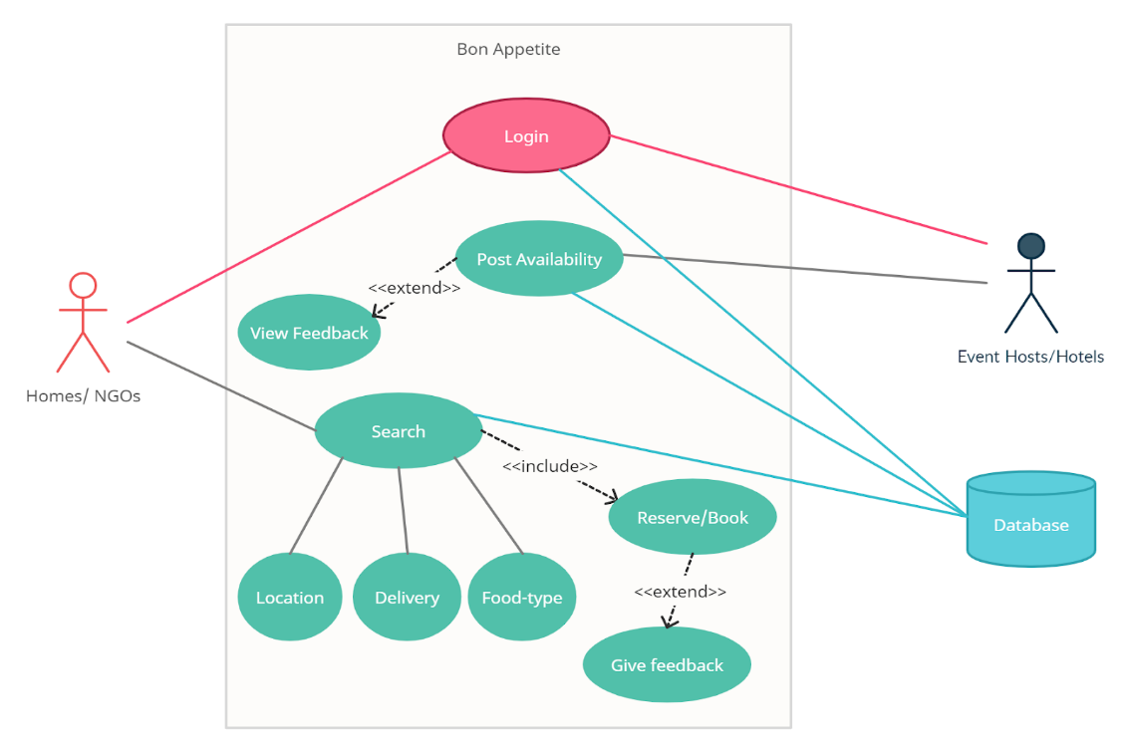

* The Food management system use cases are Login, Post Availability, view Feedback, give Feedback, Search, Reserve/Book.
* The Actors in the use case diagram are Homes/NGOs, Event Hosts/Hotels, Database.
* Homes/NGOs and Event Hosts/Hostels login with credentials to access the Database.
* Homes search for the Location, Delivery and Food-type based on that they Reserve/Book food and give their valuable feedback.
* Events Hosts/Hotels see the Post availability and view their feedback which was given by the Homes/NGOs.
* And this all will get store in the Database.
* The actors use the use case are denoted by the arrow
* **DOCUMENTATION FOR STATE CHART DIAGRAM**

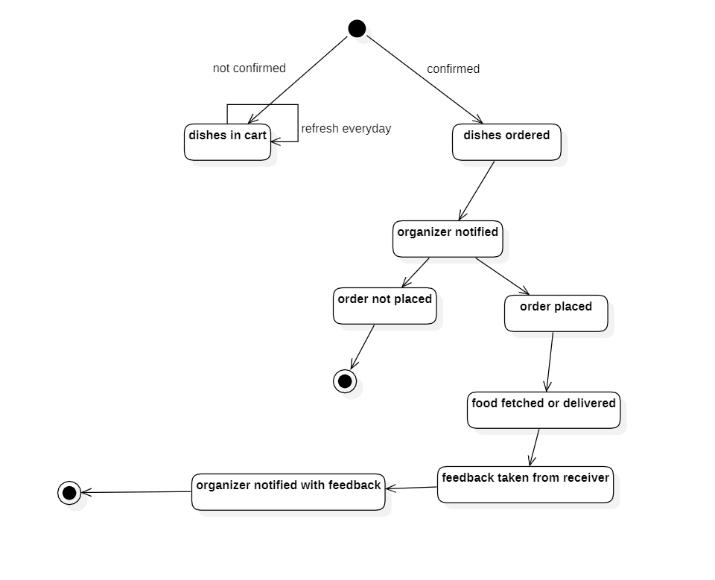.

* This is the state chart diagram of the food sharing system.
* This state chart diagram deals with the ordering of food .
* We have attributes like dishes ordered,dishes in cart,order not placed,order placed,food fetched/delivered,feedback taken from the receiver,organizer notified with feedback.
* Here dishes are available in the cart.The customer selects the food.
* The organiser notifies that some person is willing to order.If the customer places an order then the organizer delivers the food to the customer.
* After that the organizer takes feedback from the receiver .

**DOCUMENTATION OF COMMUNICATION DIAGRAM**

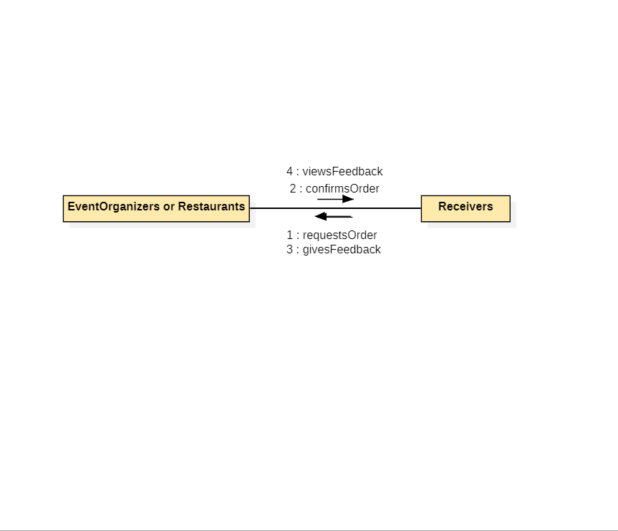

→ The receivers requests a order from the event organizations or restaurants

→ Upon receiving the request the event organizers confirm the order

→ After the service is taken place , the feedback is given according the quality and the service

**DOCUMENTATION OF CLASS DIAGRAM**

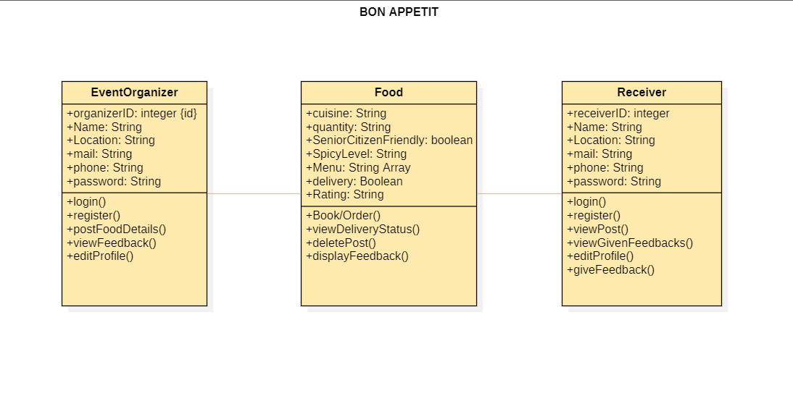

* The Event organizer has attributes such as organizer id,name,location,mail,phone,password and methods such as login,register,post food details,view feedback and edit profile.
* Food has attributes such as cuisine,quantity,senior citizen friendly,spicy level,menu,delivery,rating and methods such as book,view delivery status,delete post,display feedback.
* Receiver has attributes such as id,name,location,mail,phone,password and methods such as login,register,view post,view given feedback,edit profile,give feedback.
* Event organizer provides food to the receiver by giving all the details regarding the food type and etc..,receiver must give the feedback later on after having the food.

**DOCUMENTATION OF COMPONENT DIAGRAM**

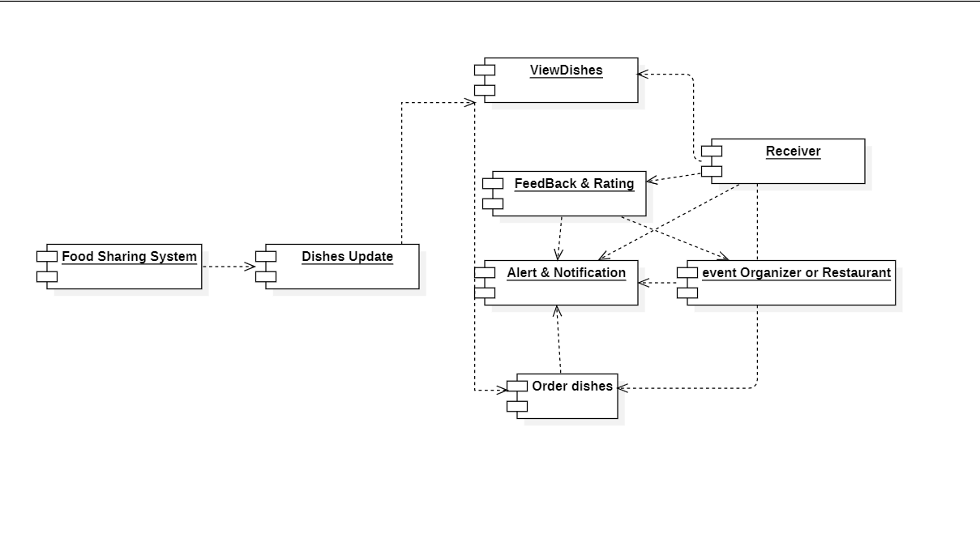

* Food sharing system has components like dishes update in which we can view the dishes.
* It has feedback and ratings which are given by the receiver after receiving food.
* It also has alerts and notifications which are sent to the receiver and event organizer or the restaurant.
* Receiver views and orders the dishes from the dishes update .

**DOCUMENTATION FOR DEPLOYMENT DIAGRAM**

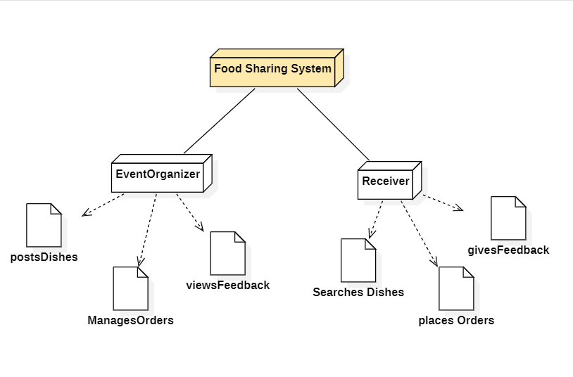

**. Food Sharing System :** food sharing system has two bodies one is event organizer and another receiver

**. Event Organiser :** the event organiser post Dishes ,manages the orders and views feedback from the customer

**.Receiver :** receiver searches the dishes which are available and place the orders and gives feedback

**DOCUMENTATION OF ACTIVITY DIAGRAM :**

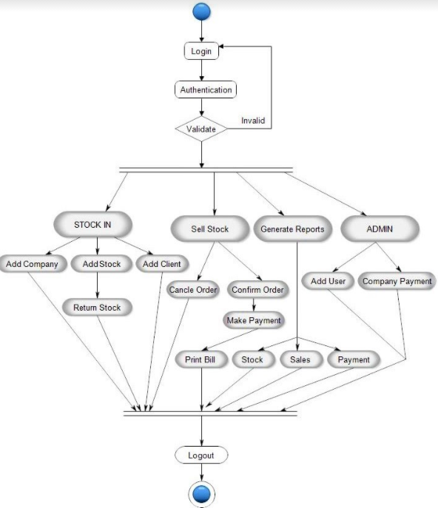

* Activity diagram is basically a flowchart to represent the flow from one activity to another activity. The activity can be described as an operation of the system.
* The control flow is drawn from one operation to another. This flow can be sequential, branched, or concurrent. Activity diagrams deal with all type of flow control by using different elements such as fork, join, etc
* The specific usage is to model the control flow from one activity to another. This control flow does not include messages.
* In the above diagram, the user can login to his account then the authentication is done. It checks whether it is a valid login or not and the process starts according to the flow and after the completion of the process the user will logout from his account.